GPs are no longer routinely prescribing medications and treatments which can be bought over the counter. Please visit your local Pharmacy for advice and over the counter medication if you or a family member are experiencing any of the following minor ailments:

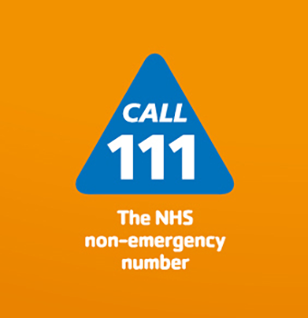
Acne (mild)
Burns and scalds (minor)
Cold sores of the lip (infrequent)
Conjunctivitis
Constipation (infrequent)
Cough colds, nasal congestion
Cradle cap
Cystitis (mild)
Dandruff
Dental caries (prevention)
Dermatitis (mild irritant)
Diarrhoea (acute) adults and children
Dry skin (mild)
Dry/sore tired eyes
Ear wax build up
Excessive sweating
Haemorrhoids
Hayfever and allergic rhinitis (mild/moderate)
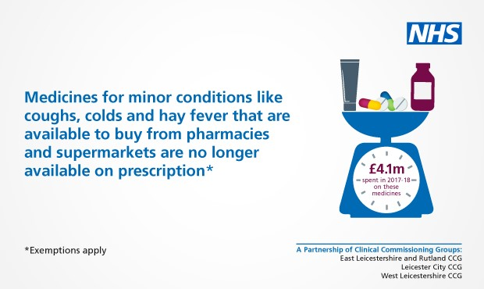
Headlice
Indigestion/ heartburn
Infant colic
Insect bites and stings
Migraine/headache (infrequent)
Mouth ulcers
Nappy rash
Oral thrush
Pain conditions (minor)
Ringworm/athletes foot
Sun burn
Sun protection
Sore throat (acute)
Teething/mild toothache
Threadworm
Thrush in men and women
Travel/motion sickness
Warts and verrucae

These are all minor ailments & self-limiting conditions that are suitable for Self Care. In the year 2016/2017, the NHS spent approximately £569 million on prescriptions for medicines which could otherwise be purchased over the counter (OTC) from a pharmacy or other outlet such as a supermarket. Advice and guidance from a Pharmacist can be really helpful with the above complaints and will often avoid an unnecessary appointment at the GP surgery. If you feel unwell, speak to your community Pharmacist as your first port of call. They will be able to recognise symptoms of a minor ailment and offer advice or treatment accordingly. They will also recognise symptoms that are more serious or persistent in nature and may recommend you seek further medical advice.

You can always call NHS 111 which will help you find the right service.

